|  |  |  |
| --- | --- | --- |
| **MODULE:** 16 | **LESSON:** 3 | BOX PLOTS |

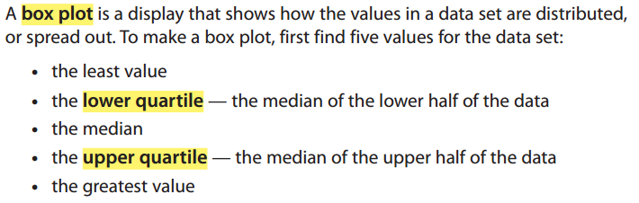

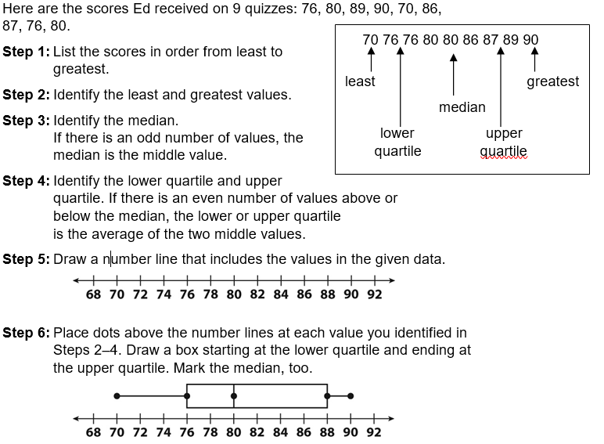

The **interquartile range (IQR)** is the difference between the upper and lower quartile.

**88 – 76 = 12**

The **range** is the difference between the greatest number and the lowest number in the data set.

**90 – 70 = 20**